**Assessment 1- Flow Chart and Pseudo Code**

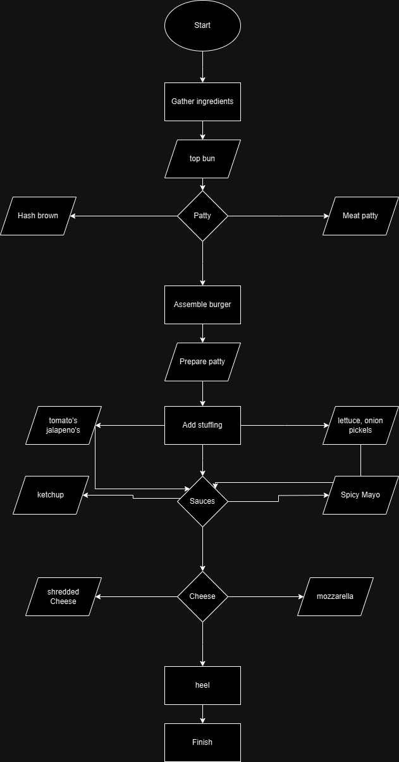

**Pseudo code of burger recipe**

- Bun crown

- Hash brown

- Meat patty

- Tomato’s Jalapeno’s

- Lettuce, onion, pickles

- Sauce’s

- ketchup

- spicy mayo

- Cheese

- Shredded cheese

- Mozzarella

- Heel

**Making**

1. **Preheat the top and end of the bun by making a cut in the middle.**
2. **Fry the Hash brown (Veg) or Meat Patty (Non-Veg) according to customer requirements.**
3. **Assemble the burger with the Requirements Tomato’s, Jalapeno’s or Lettuce, Onion’s and pickle.**
4. **Add Ketchup.**
5. **Add spicy mayo on customer requirement**
6. **Add Cheese of the requirement of Customer shredded Or mozzarella.**
7. **Place the top Bun on the assembled burger.**
8. **Then Server and Enjoy.**